# Concept Ideas:

## Mascot:

Mascot for motivating he kids.

-Owl (really good hearing)



### What is the use of such a mascot?

The mascot is a fun/cute animal that leads the kids through the game. Sometimes kids are not aware of what they have to do next, so the animal will always be present to help the kids work with the application.

This animal needs small animations e.g. showing how to click a button, how to handle a slide bar, an also make dances or clap of the kid succeeded in an activity.

## Reward System:

Gamification means rewarding the player to motivate him and make him continue playing the game.

To motivate the user, a reward system is essential to every game.

The idea for a gallery of the different elements that the kid recognized in the different stages, should motivate the kid to collect as many objects as possible. An are also able to review these objects with their specific sound.

Different stages allow the user to slowly complete its gallery. This gallery can be revisited at any time, to relisten to sounds and see the elements.

### Example of a cow:

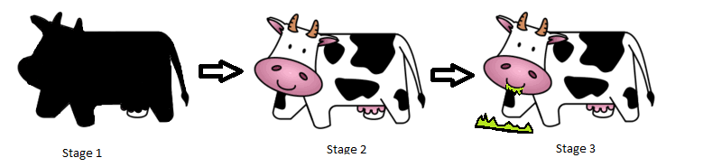

A goal could be the completion of the gallery.

### Show completion in every scene

Every scene could have a bar showing how many of the elements the kid already recognized in an earlier stage. It is an indication if it is mainly a revision or if there are elements the user didn’t collect yet.

### The gallery has a learning effect too

The gallery should not only serve the user to show the completed elements, but it should also be a revision for the different sounds, since the user is able to chose whatever element and see & relisten to its matching sound.

## Different Games with different difficulty levels.

“From Learning to Gaming and back”

The main goal of the application is to teach kids how to understand sounds and make a relation to a real-life object, person or animal.

To achieve this goal there are different games with different difficulty levels needed. These games can be divided into different stages.

## Stage 1: Explore Sounds

A scene where kids play on the beach is the example

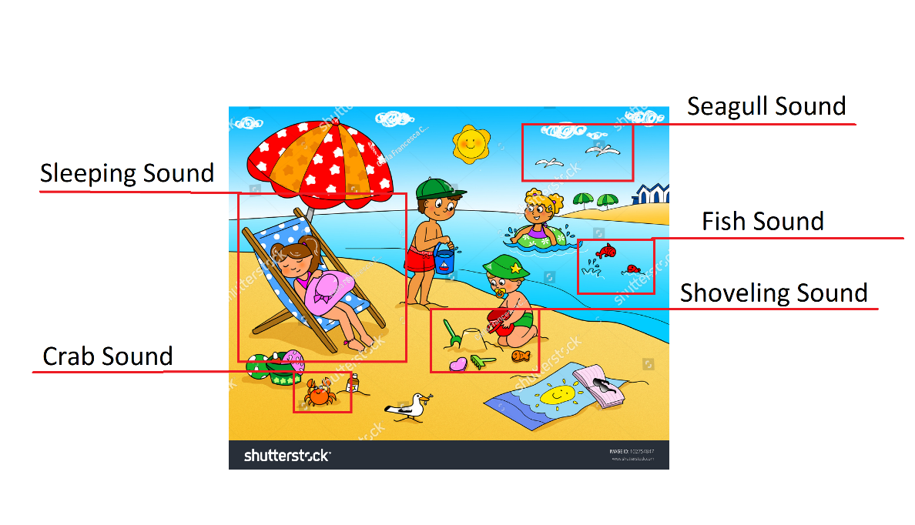

### What it looks like (example)?

The user will see a scene on the screen. The scene will consist of different elements for example a farm with different animals, a construction site with different machines, a family eating dinner or kids playing on the beach.

### What will it sound like?

The user will hear different sounds matching the scene e.g. kids talking, the waves of the ocean, the wind, a kid shoveling sand or a kid licking its ice-cream. The user is then able to tab on one of the different elements in the scene (elements will be highlighted), and only hear this specific sounds.

### What will the kid learn?

The kids will learn how the different elements in the scene sound like and how to differentiate between them. Also, the kid will be prepared on future games of the application.

### How will the kid be rewarded?

Once the kid found all the different elements with sounds in the scene the animation of the mascot will play a small dance (or various other animation) and show its appreciation. This should also motivate the kid to try and touch all the elements in the scene.

### What if the kid is stuck?

If the kid is stuck, or it can’t find the missing elements, the mascot will appear and point at the missing element. If then still the kid is not reacting the element will light up, play the sound and mark it as complete. If there are multiple missing elements this process will repeat itself after some time passed.

## Stage 2: Small Quiz

Again, we take the scene of kid playing on the beach

### What will it look like?

The kid will see 3 different elements inside of circles on the screen. The elements shown in the circles are elements from the previous scene e.g. ocean, wind, ice-cream or shoveling.

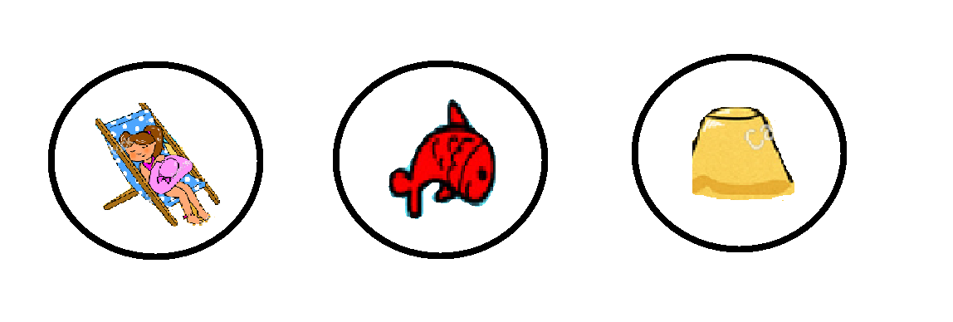

### What will it sound like?

The sound of the related object will be played repeatedly, or the kids can press a button to hear the sound again and again.

### What will the kid learn?

The kid will rather show what he has learnt so far by showing that he/she understood the different sounds. Since the kid will be corrected by the mascot It will also learn out of the mistakes it mad during the quiz.

### How will the kids be rewarded?

Again, here the mascot plays a big role by showing its appreciation if the kids is doing a good job answering to the different questions.

Here the idea of having collectable plays a big role. Each element of the kids recognized correctly can be found as a collectable. This collectable can the for example be an ocean, ice-cream a shovel etc. The collectables can later be seen in the kid’s gallery.

### What if the kid is stuck?

Again, here the mascot will help the kid to answer the quiz, this time it will not show the correct answer, but it will point on the different options the user has. If there is still no reaction after a certain time frame, the application will lead the user back to the first stage.

## Stage 3: Finding Waldo

Scene of kids playing on the beach

### What will it look like?

Just like in the first stage different elements of a scene will appear on screen.

### What will it sound like?

This time the user will only hear one sound out of the scene. The user then needs to find the matching element in the scene. It can be imagined like scene 1 but the other way around.

### What will the kid learn?

Just like in stage 2 the kid needs to make a relation between a sound and an element of the picture. This time there are more options and it is not so obvious finding the correct element.

### How will the kid be rewarded?

Again, the mascot will dance and do various other animations.

Also, the collectables will play a role since the next stage of collectable will be an animated collectable. E.g. In the second stage the user collected a shovel, now the user will find an animation of a shovel shoveling sand. This helps the kid to show how good it recognized the object.

### What if the kid is stuck?

At this stage only the different elements are highlighted by the mascot.

## Advanced Development

In a future development for the application an editor could be build that could be used by the teacher to fully customize these games.

Element could be added dynamically and scenes to be able to add these elements to a scene.

## Requirements

-Scene Images e.g. Forest, Farm, Beach, House, Rooms, Ocean etc.

-Elements e.g. Animals, Objects, Humans etc.

-Sound for the different elements

-Background noises for the different scenes e.g. Forest (Leaves whistling sound), Ocean (sound of waves or bubbles)

-Mascot (Owl) with different animation e.g. pointing at elements, dancing, compliments

-Elements for rewards (blacked out, normal, animated)

-Functionalities of the 3 different stages

-Data should be collected in the background for later analysis for the parents/teachers.